Trauma-Informed Care Toolkit #1

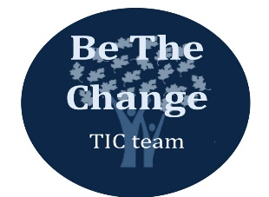

Introduction to Trauma

The purpose of this toolkit is to provide an overview of:

- What is trauma?

- What is secondary trauma?

- What is trauma-informed care (TIC)?

- Additional resources

If you have any questions, contact: tic@preferredbehavioral.org

What is trauma?

“A single event, multiple events, or a set of circumstances that is experienced by an individual as physically and emotionally harmful or threatening that has lasting adverse effects on an individual’s physical, social, emotional, or spiritual well-being.”
SAMHSA, 2012

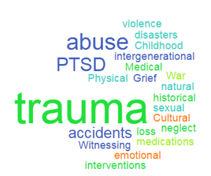

PBHG Staff Definition of Trauma:

Any type of distressing event that results in an overwhelming amount of stress that exceeds one’s ability to cope, or integrate emotions involved with that experience.

Types of Trauma

- Acute Trauma: One-time incident (i.e. car accident, rape)

- Complex: Occurs over time (i.e. abuse, domestic violence)

- Crossover Trauma: Event with lasting effects (i.e. Superstorm Sandy, illness)

- Vicarious Trauma*: Being affected by hearing about trauma (clinicians, translators, etc.)

- Secondary Trauma*: #4 with PTSD symptoms (flashbacks, fear, etc.)

- Compassion Fatigue*: Feeling numb/burnt out by caring for victims of trauma

*Mental health employees are most susceptible to #4-6.

An individual’s thoughts, feelings, and behaviors are filtered through their own experience and perspective.

Trauma by Numbers: 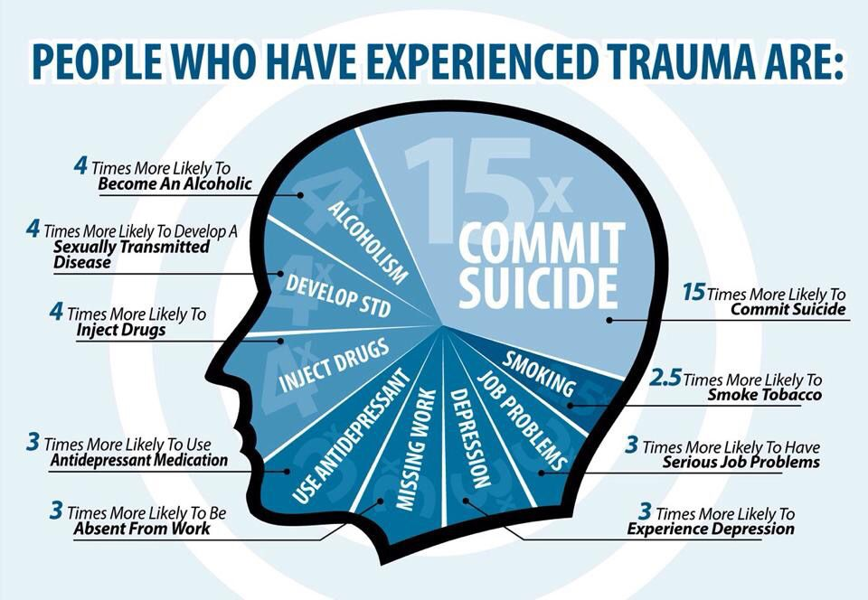
90% of persons with a mental health
diagnosis have experienced a trauma.
It is estimated that 7 out of 10 Americans
have been exposed to trauma.
(Mueser et al, 2004, as cited in Unick, Bassuk, Richard, & Paquette, 2019; SAMHSA, 2014)

What are ACEs?

Adverse childhood experiences (ACEs) are stressful or
traumatic events, including abuse and neglect.

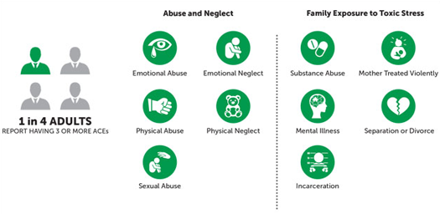

ACEs are strongly related to a wide range of
health problems including substance misuse.

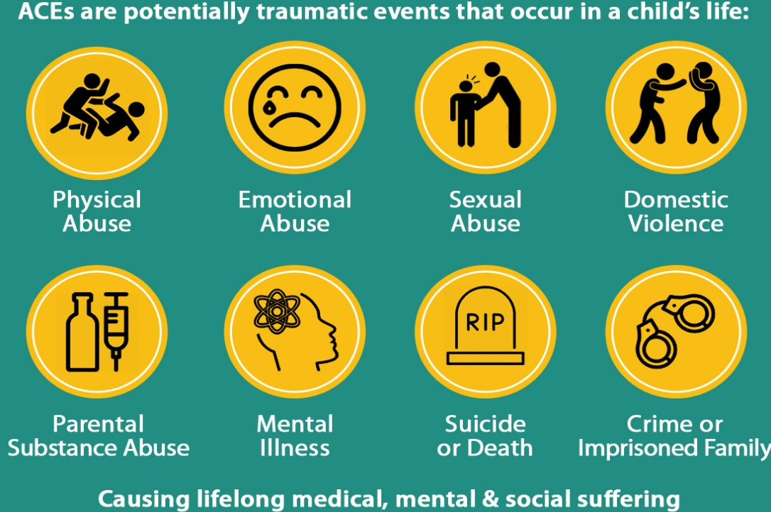
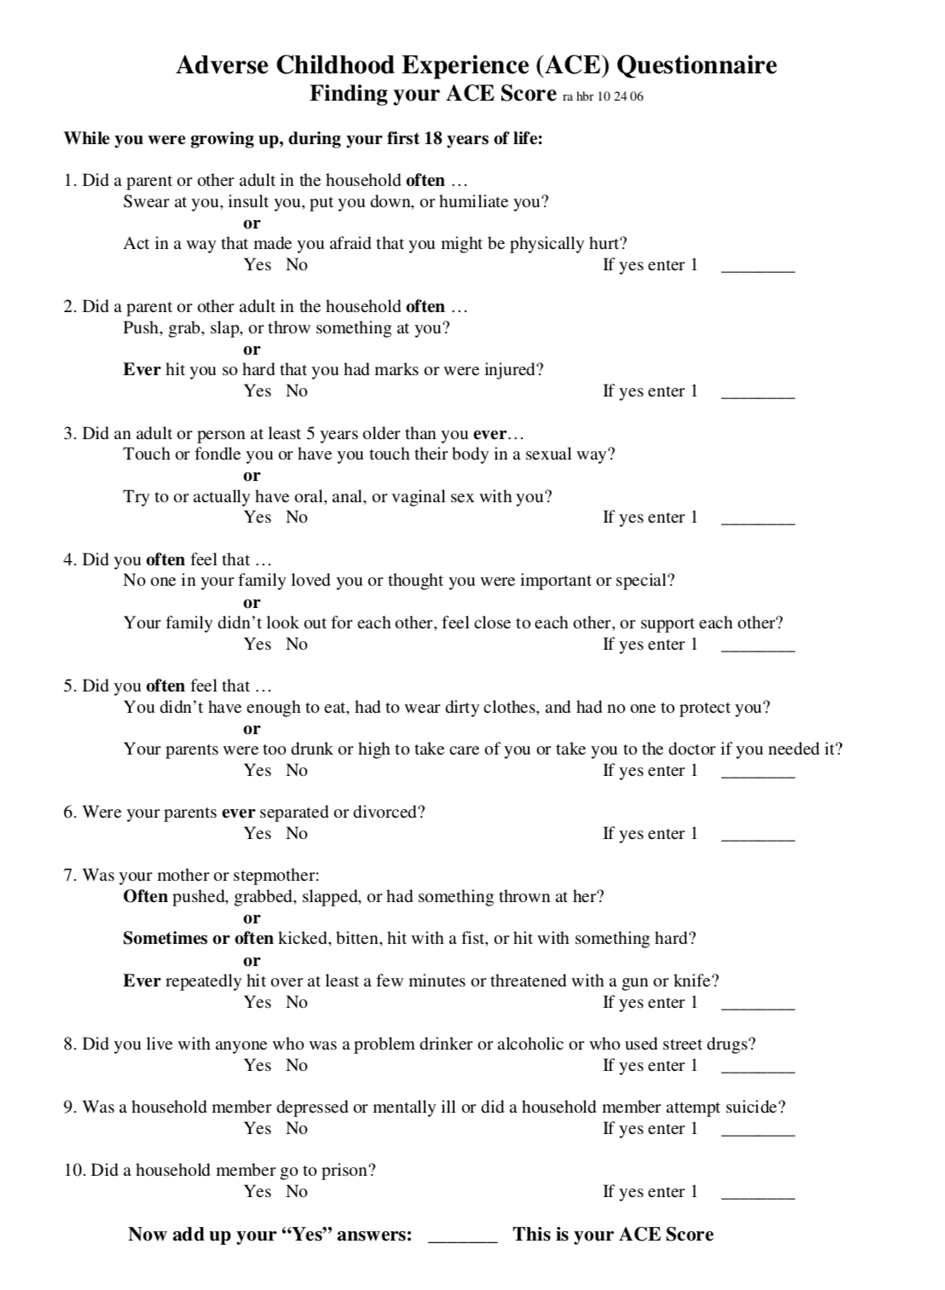
Know Your Score
What is Trauma-Informed Care?
A framework of thinking and acting, which is directed by understanding the profound neurological, biological, psychological, and social effects trauma has on an individual.
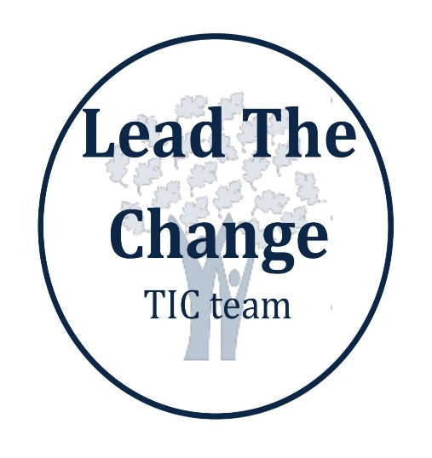
Creates an environment that emphasizes physical, psychological and emotional safety for clients AND staff.

A Trauma-Informed approach
views a person from a
“what’s happened to you?” perspective
vs.
“what’s wrong with you?”
Trauma-Informed individuals use “I” statements when speaking and approach people with compassion.
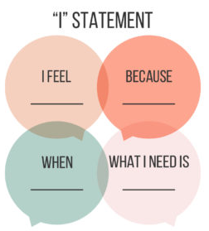

Benefits
- Creating safer physical and emotional environments

- Reducing the possibility of re-traumatization

- Creating environments that care for and support staff

- Increasing the quality of services

- Reducing the number and types of negative encounters and events

- Increasing client and family satisfaction

- Increasing success and job satisfaction among staff

PBHG TRAUMA-INFORMED DOMAINS
(Toolkits)

- Trauma Education
- Safety (Physical & Emotional)
- Health and Wellness
- Training
- Ongoing Commitment to Trauma-Informed Philosophy
TRAUMA INFORMED CARE IS A PROCESS…NOT A DESTINATION.
“Everyone has a right to have a future that
is not dictated by the past.”
~Karen Saakvitne

Trauma-Informed Resources

Helpful Videos:
https://tinyurl.com/TICTedTalk

https://tinyurl.com/youtube4PBHG

https://tinyurl.com/youtubePBHG2

https://tinyurl.com/youtubePBHG3

https://tinyurl.com/youtubePBHG4

Informational Websites:

https://www.helpguide.org/articles/ptsd-trauma/coping-with-emotional-and-psychological-trauma.htm/ or https://tinyurl.com/helpguideTIC

https://store.samhsa.gov/system/files/sma15-4420.pdf or https://tinyurl.com/samhsasite

https://www.traumainformedcare.chcs.org/what-is-trauma/ or https://tinyurl.com/whatistrauma

https://alamedacountytraumainformedcare.org/trauma-informed-care/what-is-trauma/ or https://tinyurl.com/TICwhatistrauma

